- Copyright for test papers and marking guides remains with West Australian Test Papers.
- The papers may only be reproduced within the purchasing school according to the advertised conditions of sale.
- Test papers must be withdrawn after use and stored securely in the school until Wednesday 5th December 2012.

PHYSICS

YEAR 11

STAGE 2A/2B

2012



SOLUTIONS

Section A 80 marks = 40%
Question 1
a) The refrigerator uses the principle of latent heat of vaporisation to cool the inside cabinet and its contents and is insulated to minimise heat transfer between the inside and the outside. A refrigerant is circulated through pipes in the refrigerator walls and is alternatively compressed and expanded so latent heat of vaporisation is extracted from the inside of the cabinet in the process thus cooling the contents (bottle of water) (3 marks)
b) As the thermostat in the refrigerator is set at 4 ºC, the temperature in the cabinet will not fall below that temperature. As water freezes at 0 ºC, the water will remain in the liquid phase.
(1 mark)
Question 2
a) The deceleration of the ball in the upward direction and the acceleration in the downward direction are equal in magnitude (9.8 m s⁻² if air resistance is ignored). Therefore the time for its ascent and descent will be equal because it is travelling the same distance under identical conditions. Alternatively, the force acting on the ball while ascending is equal to the force during its descent. (2 marks)
b) (i) 0 m s⁻¹ (1 mark)
(ii) 9.8 m s⁻²down (1 mark)

Question 3
a) The filament is a non ohmic conductor that has a high resistance. It is this high resistance that causes the electrical energy to be converted into heat and light. The conducting wires are ohmic resistors and have a relatively low resistance that allows electrical energy to be conducted with only a small quantity of energy being lost in the process. (2 marks)
b) Compact fluoro globes are more environmentally friendly because they use a different technology to incandescent globes, which makes them capable of converting electrical energy into light energy more efficiently. Less energy is lost to heat (they run cooler) and they are cost effective because they have a life time many times greater than an equivalent incandescent globe. (2 marks)
Question 4
A dimmer is essentially a variable resistor. As the resistance in a circuit is changed so the current is altered and the quantity of energy being delivered to lights is either increased (lights are brighter) or reduced (lights dim). The dimmer, which is usually in series with the light to be affected, is operated by knob or lever that changes the resistance in the circuit. (3 marks)

Question 5
a) mass of golf ball = 0.05 kg
velocity of club = 150 km h⁻¹ = approx 40 m s⁻¹
initial momentum = 0 kg m s⁻¹

final momentum = m x v = 0.05 x 40 = 2.0 kg m s⁻¹ (2 marks)
Change in momentum = 2 – 0 = 2.0 kg m s⁻¹

b) Ball’s speed changes from 0 m s⁻¹ to 40 m s⁻¹ in 0.2 s
acceleration of the ball = 40 / 0.2 = 200 m s⁻²
F = m x a
F = 0.05 x 200 = 10.0 N (2 marks)
c) The constant swinging of golf clubs at such high velocities and impacting with the stationary ball places a constant strain on the golfers arms and shoulders as they swivel from high to low trajectories. This may lead to repetitive strain injuries of the shoulder. (1 mark)
Question 6
a) Resistance in the parallel circuit = 1/R_{T} = 1/R₁ + 1/R₂
1/R_{t} = 1/8 + 1/32 so 1/R_{T} = 5/32
so R_{T} = 32/5 = 6.40 Ω
Total resistance in the series circuit = R_{T} = R₁ + R₂ = R₃
R_{T} = 16 + 20 + 6.4 = 42.4 Ω ( 3 marks)
b) The 16 Ω and 20 Ω resistors will both carry the same current which will be greater than the currents carried by either the 8 Ω or 32 Ω resistors.
In a series circuit all resistors carry the same current. Because the 8 Ω and 32 Ω resistors are in parallel they will carry only proportions of the total current. (2 marks)
Question 7
a) Western Australia receives a large proportion of solar energy compared to other parts of the world. The climate (long summers with clear skies) means solar hot water systems receive an adequate exposure to sunlight to sustain their use economically. (2 marks)
b) Rate of absorption of energy = 1700 J s⁻¹
In 45 min energy absorbed = 1700 x (45 x 60) = 4.59 x 10⁶ J
To calculate rise in temperature of water.
Q = m c ΔT
4.5 x 10⁶ = 17 x 4180 x ΔT
ΔT = 64.6 ºC (3 marks)

c) The major assumption is that the water is not circulating. In reality the water would be circulating in the heater due to convection currents. This would alter the rate of heating because the total amount of water in the storage tank is being heated (2 marks)

Question 8
a) 1 becqueral = 1 count per second
560 / (60 x 60) = 0.16 Bq (2 marks)

b) The relic is older. As its count is 0.16 Bq compared to the reference piece (0.311 Bq) the relic has decayed from its original living situation for a longer time to reach a count of 0.16 Bq. (3 marks)
c) All living and once living organisms contain carbon. Any sample of carbon contains a proportion of the radioactive isotope carbon–13. Over time the carbon-13 decays with a half life of 5720 years. When a living species dies the decay commences and when the decay rate is measured many years later, and compared to a known reference sample of carbon, the age can be determined. (2 marks)
Question 9
a) Initial velocity = 0 m s⁻¹
final velocity after 2.5 s = 15 m s⁻¹

acceleration = (15 – 0) /2.5 = 6.00 m s⁻² (2 marks)

b) F = m a
F = 1.5 x 10³ x 6.0 = 9.0 x 10³ N
Average force required = 9.0 x 10³ N (3 marks)
c) constant speed is 15 m s⁻¹
force = 2.5 x 10³ N
power = F x v
power = (2.5 x 10³) x 15 = 3.75 x 10⁴ W (3 marks)
Question 10
a) (i) 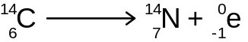 (beta particle) (1 mark)
(ii) 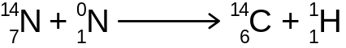 (proton) (1 mark)
b)
(i) 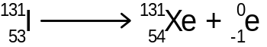 (1 mark)
(ii) 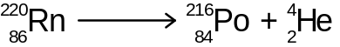 (1 mark)

Question 11 (3 marks)
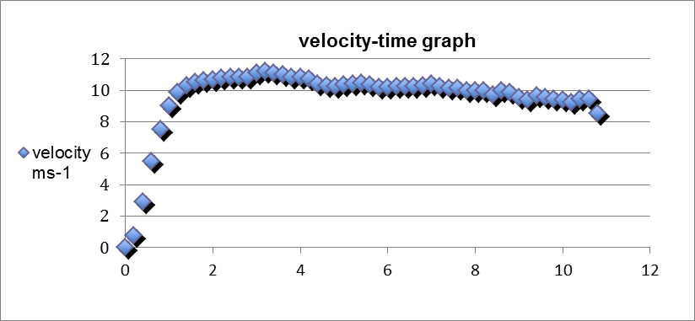
Time (s)
Question 12
a) Heat loss by ice = Heat gain by water
(m x L) + m c ΔT = m c ΔT
(m x 3.34 x10⁵) + (m x 4180 x 5) = (0.75 x 4180 x 17)
3.34x10⁵ m + 20 900 m = 53 295
3.549 x 10⁵ m = 53 295
m = 53 295 / 3.549 x 10⁵ = 0.150 kg (4 marks)
b) Add the ice to the water in the largest pieces possible. The larger pieces, because of their smaller surface area, melt more slowly and hence maintain the water at a colder temperature for longer. (2 marks)
Question 13
a) To change the temperature of 5.0 g from 25 ºC to 100 ºC
Q = m c ΔT
Q = 0.005 x 4180 x 75 = 1567.5 J = 1.57 x 10³ J (assuming no energy losses) (3 marks)
b) To convert the water into steam
Q = m x L = 0.005 x (2.26 x 10⁶) = 1.13 x 10⁴ J (2 marks)
c) Total energy required = 1567.5 + (1.13 x 10⁴) =12 867.5 J
P = V²/R
P = 240² / 50 = 1152 W
P = E/t so t = E/P = 12 867.5 / 1152 = 11.2 seconds (4 marks)
Question 14
a) From the graph the half life is 6 hours ( + or - 1 hour). (Students should take more than 1 reading from the graph and average the half lives to be given full marks.) (3 marks)
b) 60 000 Bq (2 marks)
Question 15
If the circuit is fitted with an electronic circuit breaking device that detects a minute imbalance in current between the active and neutral wires then the electricity to the washing machine circuit will be cut off the instant the person touches the casing, thus saving the person from an electric shock. (3 marks)
If the circuit breaker is not installed or is not operating properly then the current will flow, through the person touching the casing, to earth and in the process will provide the person with an electric shock. Most of the current will flow to earth through the earth wire. (3 marks)

END OF SECTION A
Section B 100 marks = 50 %
Question 1
a) KE = ½ m v² = ½ x 40 x 6² = 720 J (2 marks)
b) (Energy lost (work done) to friction on the ramp = F x d
= 30 x 5 = 150 J
So the total energy of the box = 720 + 150 = 870 J
This is the energy the box would have at the top of the ramp which is its potential energy.
PE = m g h = 870 = 40 x 9.8 x h
So height is 870 / 40 x 9.8 = 2.22 m (4 marks)
c) No. The two energies are not equal. Some of the potential energy has been consumed as work done against friction so the PE will be greater than the KE. (2 marks)
d) Yes. The boxes will continue to accelerate until they reach their terminal velocity. The terminal velocity may not be reached in the short distance the boxes travel. (2 marks)
e) initial velocity 0 ms⁻¹
g = 9.8 m s⁻²
d = 2.22 m
v² = u² + 2 a s
v² = 0² + 2 x 9.8 x 2.22
final velocity is 6.60 m s⁻¹
OR
ΔPE = ΔKE
870 = ½ x 40 x v²
v² = 43.5
v = 6.60 m s⁻¹ (3 marks)

Question 2
a) Absorbed dose = energy / mass = 70/65 = 1.08 Gy (2 marks)
b) Dose equivalent = Absorbed Dose x quality factor
= 1.08 x 1 (beta source) = 1.08 Sv (2 marks)
c) Dose Equivalent (alpha particles) = 1.08 x 20 = 21.6 Sv (2 marks)

d) An absorption of 1.08 Sv would cause nausea and vomiting whereas an absorption of 21.6 Sv would probably result in death. (1 mark)
e) i (3 marks)
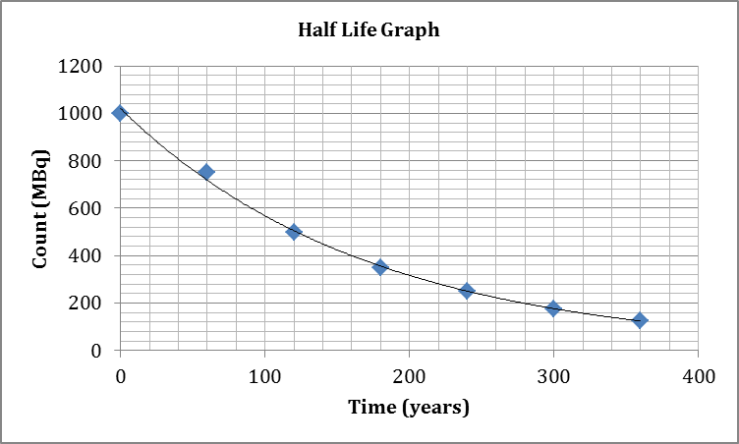

e)ii After 300 years the activity is 160 MBq (plus or minus 20 MBq) (2 marks)
Question 3
a) ₉₂U²³⁵ + _{o}n¹ → ₅₆Ba¹⁴⁴ +₃₆Kr⁸⁹ + 3_{o}n¹ (2 marks)
b) LHS RHS
(3.90 x 10⁻²⁵) + (1.67 x 10⁻²⁷) (2.34 x 10⁻²⁵) + (1.52 x 10⁻²⁵) + (3 x 1.67 x 10⁻²⁷)
(3.9167 x 10⁻²⁵) – (3.9101 x 10⁻²⁵) = 0.0066 x 10⁻²⁵
E = m c² = 0.0066 x 10⁻²⁵ x (3.00 x 10⁸)²
Energy = 5.94 x 10⁻¹¹ J (5 marks)

c) 200 MW =200 x 10⁶ J s⁻¹
For 1 year [200 x 10⁶ x (365 x 24 x 60 x 60)] J of energy are required
3.90 x 10⁻²⁵ kg of uranium can produce 5.94 x 10⁻¹¹ J
[200 x 10⁶ x (365 x 24 x 60 x 60)] / 5.94 x 10⁻¹¹ J = 1.0618 x 10²⁶ J
so quantity of uranium –235 = (1.0618 x 10²⁶) x (3.9 x 10⁻²⁵)
= 41.4 kg (6 marks)
Question 4
a) Resistance in the BC parallel circuit is 6 Ω
Resistance in the CD circuit is 5 Ω
Total resistance in the circuit is 4 Ω + 6 Ω + 5 W = 15.0 Ω (3 marks)

b) V = I R
120 = I x 15
Current (I) is 120/15 = 8.0 A (2 marks)

c) V = I x R
V = 8.0 x 4 = 32.0 V (2 marks)
d) The answer is B (1 mark)
e) Current in a series circuit is equal in all parts of the circuit. Only when the current is divided when it is in a parallel part of the circuit will it have a different value. (2 marks)
f) q = I t
q = 8.0 x 120 = 960 C (2 marks)
g) 1.5 MJ
E = V I t
1.5 x 10⁶ = 120 x 8.0 x t
t = 1.5 x 10⁶ / (120 x 8.0) = 1562.5 seconds
Time = 1562.5 s = 26.0 minutes (3 marks)
Question 5
a) Heat lost by steam = Heat gained by water.
(m L) + (m c ΔT) = m c ΔT
(0.022 x L) + 0.022 x 4180 x 20 = 0.205 x 4180 x 59
L = [(0.205 x 4180 x 59) – (0.022 x 4180 x 20)] / 0.022
L = 4.8717.9 x 10⁴ / 0.022
L = 2.21x 10⁶ J kg⁻¹ (4 marks)
b) {(2.26 x 10⁶) – (2.214 x 10⁶) / (2.26 x 10⁶)} x 100 = 2.04 % (2 marks)
c) Yes. This is a very, very good result using the equipment supplied. Any percentage error less than 5% in these circumstances would be acceptable. (2 marks)
d) The long delivery tube could cause steam to condense in the tube so water, not steam, may enter the styrofoam cup thus producing an error in the calculation. (2 marks)
Question 6
a) momentum = mass x velocity (velocity is 23.6 m s⁻¹)
momentum = 2150 x 23.6 = 5.08 x 10⁴ kg m s⁻¹ (2 marks)
b) v² = u² + 2a s
23.6² = 0² + 2 a x 200
a = 23.6² / 400 = 1.39 m s⁻²
F = m x a = 80 x 1.39 = 1.11 x 10² N (3 marks)
c) It depends whether the acceleration is uniform or not. If the acceleration is uniform the force
will be constant. If the plane is accelerating at different rates then the force will vary
accordingly. (2 marks)
d) Average speed if there is no headwind
150 /1.0 = 150 km h⁻¹
However the headwind is 20 km h⁻¹
Therefore the aircraft will need to fly at a speed of 170 km h⁻¹ (3 marks)
e) s = ut + ½ a t²
s = 16 x 10 + ( ½ x -2 x 10²)
s = 160 - 100 = 60 m (2 marks)
f) mass of aircraft = 2150 kg
deceleration = 2 m s⁻²
Force = m x a = 2150 x 2 = 4.30 x 10³ N (2 marks)
Question 7
a) During this time the substance is undergoing a phase change. Energy that is absorbed by the substance is being used to break bonds that exist between molecules/atoms of the solid. Therefore there is no rise in temperature until all the substance has changed phase.
b) -39 ºC (1 mark)
c) 357 ºC (1 mark)
d) 1.26 x 10⁴ J kg⁻¹ (2 marks)
e) 2.85 x 10⁵ J kg⁻¹ (2 marks)
f) No. The substance is not water. The two values, latent heat of fusion and latent heat of vaporisation, do not agree with the accepted corresponding values for water. (1 mark)
Question 8
a) When the plastic is rubbed electrons are transferred from the cloth to the rod producing a negatively charged rod. Because the rod is an insulator the electrons do not move along the rod. The cloth, having lost electrons, becomes positively charged. (2 marks)
b) The paper, being at zero potential with respect to the negatively charged rod, is attracted to the rod because of the difference in potential. (2 marks)
c) After some time the electrons that have accumulated on the rod drift to the paper. When the potential of the rod and paper are equal, there is no more attractive force so the paper falls away from the paper. (2 marks)
d) Copper is a good conductor so if electrons are transferred to the rod they are conducted along the rod and to earth so no charge accumulates. (2 marks)
e)
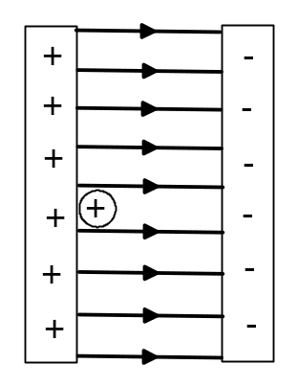 (2 marks)

f) q = 1.60 × 10⁻¹⁹ C V = 12.0 V m_{proton} = 1.67 × 10⁻²⁷ kg (data sheet)
KE_{initial} = 0 KE_{final} = ½ m v²
(use absolute value of charge as v is scalar)
W = q.V = ΔKE = KE_{final} - KE_{initial}
q.V = ½ m v²
1.60 × 10⁻¹⁹ × 12.0 = ½ × 1.67 × 10⁻²⁷ × v²
v² = 22.994 × 10⁸ so
v = 4.80 × 10⁴ m s⁻¹ (5 marks)

END OF SECTION B

Section C - 20 marks = 10%
Question 1
- 20 s plus/minus 2 s (2 marks)

- 205 m s⁻¹ (2marks)

- Approximately 50 s (2 marks

- Approximately 8 m s⁻² (plus or minus 1 m s⁻²) (3 marks)

- v_{sound} = (331.3 + 0.606 T)
205 = (331.3 + 0.606 T)
205 – 331.3 = 0.606 T
T = - 126.3 / 0.606 = -208 ºC (3 marks)

- Air resistance will slow him down (1 mark)

- According to the amateur skydiver’s graph Felix will reach the speed of sound a little earlier
(22 s) than the 35 s as predicted by the official sponsor. (2 marks)

- Using the graph: rise /run = (5000 - 0) / 80 = 62.5 m s⁻¹ (2 marks) Or from graph 1: (75 + 55)/ 2 = 65.0 m s⁻¹

9(a) 62.5 x (3600 / 1000) = 225 km h⁻¹ (1 mark)

9(b) 225 km h⁻¹ is a very high impact speed and is an unrealistic speed with which any sky diver
would reach the ground. (2 marks)

END OF EXAM

